Analysis of Performance and Energy Consumption of Wearable Devices and Mobile Gateways in IoT Applications
ABSTRACT
Smartphones and wearable devices, such as smart watches, can act as mobile gateways and sensor nodes in IoT applications, respectively. In conventional IoT systems, wearable devices gather and transmit data to mobile gateways where most of computations are performed. However, the improvement of wearable devices, in recent years, has decreased the gap in terms of computation capability with mobile gateways. For this reason, some recent works present offloading schemes to utilize wearable devices and hence reducing the burden of mobile gateways for specific applications. However, a comprehensive study of offloading methods on wearable devices has not been conducted. In this paper, nine applications from the LOCUS’s benchmark have been utilized and tested on different boards having hardware specification close to wearable devices and mobile gateways. The execution time and energy consumption results of running the benchmark on the boards are measured. The results are then used for providing insights for system designers when designing and choosing a suitable computation method for IoT systems to achieve a high quality of service (QoS). The results show that depending on the application, offloading methods can be used for achieving certain improvements in energy efficiency. In addition, the paper compares energy consumption of a mobile gateway when running the applications in both serial and multithreading fashions.
EXISTING SYSTEM
Due to the resource constrained nature of wearables in terms of battery power and processing capability, these devices often rely on a mobile device (mobile gateway) such as a smartphone for performing the edge processing of the IoT application. In conventional IoT systems, wearable devices gather and transmit data to mobile gateways where most of computations are performed. However, the improvement of wearable devices, in recent years, has decreased the gap in terms of computation capability with mobile gateways. For this reason, some recent works present offloading schemes to utilize wearable devices and hence reducing the burden of mobile gateways for specific applications. However, a comprehensive study of offloading methods on wearable devices has not been conducted.
Disadvantages of Existing System:
- The improvement of wearable devices, in recent years, has decreased the gap in terms of computation capability with mobile gateways.
- A comprehensive study of offloading methods on wearable devices has not been conducted.
PROPOSED SYSTEM
In this paper, we investigate and analyze the performance and energy consumption of four different wearable and gateway devices while they are running 9 diverse applications, ranging from a simple encryption or decryption algorithm to a complex machine learning program. The wearable devices and the selected mobile gateways are compared when running the LOCUS benchmark which includes a broad range of real-time IoT applications that can be executed on wearable and mobile gateway devices. In addition, we compare the energy consumption of a mobile device while running 9 applications of the LOCUS benchmark in both serial and multi-threading manners. The paper presents practical insights for system designers when choosing a suitable computation method (i.e., offloading method) for IoT systems in order to achieve a high quality of service (QoS).
Advantages of Proposed System:
- We compare the energy consumption of a mobile device while running 9 applications of the LOCUS benchmark in both serial and multi-threading manners
- The results show that the chosen mobile gateway device has higher performance and is more energy efficient compared to the chosen wearable devices but according to the type of the application, the performance and energy consumption gap differ.
- The results also indicate that the wearable processors are weaker in executing applications that contain complex computations, offloading techniques should consider offloading simple operations onto wearable devices
SYSTEM IMPLEMENTATION
System Architecture
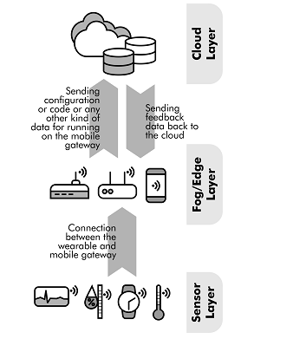
Figure 1: Fog-based IoT applications computing structure
SYSTEM REQUIREMENTS

Hardware Requirements:

Processor - Pentium –IV
- Speed - 1.1 GHz
- Ram - 256 MB
- Hard Disk - 20 GB
- Key Board - Standard Windows Keyboard
- Mouse - Two or Three Button Mouse
- Monitor - SVGA
Software Requirements:
- Operating System - Windows XP
- Coding Language - Java

